**Assignment 1** Understanding the Other Side (High School SS)

Immerse yourself in a viewpoint within a larger controversy that you strongly disagree with or have a hard time understanding. Write a paper describing this group’s beliefs and values fairly and accurately. What makes this group tick? What are their core beliefs and values?

How do you know if you’ve achieved this goal? Ask yourself, “Would someone from this group I’ve examined agree with my representation of their beliefs? Would they say that I gave their beliefs a fair examination and that I captured their core values?”

It’s easy to write about ideas we already believe in. The real challenge is examining ideas or beliefs that make us uncomfortable, upset, or uneasy.

This paper should:

* Be approx. 6-8 pages
* Cite at least 10 quality sources
* Explain how the viewpoint you’re discussing fits into the larger controversy (this would be appropriate in the introduction or in the first few paragraphs of the body)

**Assignment 2**

**A picture of the sculpture is called “Hannah’s Prayer” by Suzanne Miller.**

Take a minute to look at the sculpture. What do you see?

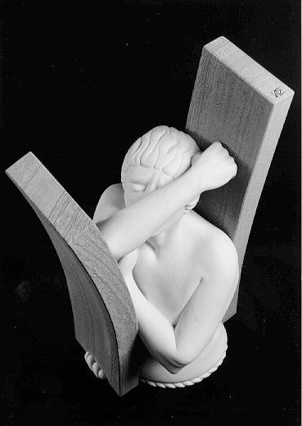

Does this image work for you as a vehicle to talk about Sethe in Toni Morrison’s *Beloved*? Does it work for Baby Suggs? Does it speak to you in different ways when you consider Baby Suggs versus Sethe?

**Assignment 3**

Explain Andrew Jackson’s actions and decisions regarding Native American Removal and the Bank of the United States. How did these actions reflect Jackson’s use (or abuse) of Executive Power?

Native American Removal-

Bank of the US-

Executive Branches Power-

**Assignment 4**

Problem 1: Estimation (see section 1.10 in course notes)

In a recent publication of Nature, Australian scientists determined that during the last ice age (22,000 to 19,000 years ago) the sea level reached its low point, 425 to 440 feet below the present level due to the change of sea water to glacial ice.

1. What approximate volume of ice would this correspond to?
2. If this additional ice were evenly divided between the polar ice caps, estimate how far the northern hemisphere ice sheet would extend southward.

Problem 2: Kinematics (see chapter 2 notes)

Two stones are released from rest at a certain height, one after the other.

1. Will the difference in their speeds increase, decrease, or stay the same?
2. Will their separation distance increase, decrease, or stay the same?
3. Will the time interval between the instants at which they hit the ground be smaller than, equal to, or larger than the time interval between the instants of their release?

The students are provided with a selection of three brands of microwave popcorn. In groups of four  students, they decide on a question for investigation and then design an experimental procedure. During  the investigation, students will record data, which they will graph and analyze to provide an answer to the  investigation question they pose.  Day One: The Investigation

1. Review with students what the word “observation” means. Discuss how they collect information and  what information to collect during an investigation, such as measuring mass, size, volume, time, etc.

2. Divide students into groups of four as described under “Getting Ready.” Show the class what is on the  table for them to use and list on the board what else can be used that is not in the room (e.g., refrigerator,  freezer). Students may need some time to explore the materials before they are ready to pose a question.

3. Hand out the assignment and say, “In your groups discuss potential questions to test and begin to think of ways to investigate their ideas. Appendix 1, “Forming Your Question” will help guide your group through the process. Be sure to write down your question, make a prediction, and then list out the steps your group will follow to  investigate. you should be collecting number data that you’ll   graph on Day Two. Be sure to write in your journals. Be sure to record the question that  they will be investigating in their journal and to write their plan for how they will investigate.

4. Collect the questions and plans from each group, and discuss them with the groups. Once you have  approved the question and plan, have the groups work on their own to carry out the investigation.  Circulate around the room, asking guiding questions and assisting groups with the microwave, freezer,  and refrigerator as needed. Investigations may carry over to Day Two. Make sure that students are  recording their data into their science journals using an organized format (data table) for use on Day Two  in analysis.

*Molly’s Pilgrim* Project Assessment

Choose a project from the list below or create one of your own that is approved by the teacher.

* Interview their parents about their ethnic background and do research to create a doll wearing a native costume from the country your ancestors came from.
* Create a family tree.
* Do research on ethnic foods and with parental help prepare and serve and ethnic meal containing dishes from different ethnic backgrounds.
* Combine recipes into a cookbook for all members of the class.
* Look in a telephone book to find one family name for each letter of the alphabet and make a list.
* Do research into holidays unique to the country from where your ancestor come from. Present this to the class orally.

Assignment 3

Title:  *The Other Side*

Author: Jacqueline Woodson Genre: Fiction Mini Lesson: Reading Skill: Author’s

|  |  |  |
| --- | --- | --- |
| Author’s write for a purpose. Many authors write to teach a lesson. The story we will read today teaches a life lesson. As we read the story, we will stop and gather clues that lead us to the lesson. | Why do you think the author wrote *The Other Side*? Show cover of the book | Students respond to the question with their peer partner. |
| Read Page 1 | Why do you think Mama said it wasn’t safe to climb the fence? | Turn to your peer partner to answer the question |