Four faces of Mathematics Identity

Engagement  How students engage with mathematics in the classroom  - Types of tasks students engage in  - What is valued as mathematical thought  - Whose thought is valued | Imagination  Images one has of herself and of how mathematics fits into the broader experience of her life in terms of:  - Course-taking trajectories  - Postsecondary choices  - Standardized test achievement
Alignment  How students align their energies with institutional boundaries and requirements such as:  - Considering advanced-level mathematics courses  - Satisfying standardized test requirements | Nature/Ability  Who we are based on what nature gave us at birth  - “Who” defined by attributes such as race and gender  - “Who” defined by attributes such as a natural inclination for success in mathematics or a “math gene”
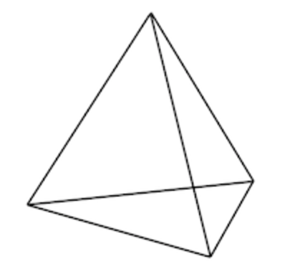

Engagement
Create classroom environments where students feel mathematics is their “scholarly home” and that their ideas are valued via the assignments provided
-Alignment of tasks with CCSSM at the appropriate levels of rigor and cognitive demand
-Create tasks that generate discussion and sharing
Organize mathematics tasks in ways that allow students to express themselves creatively and communicate their meanings of mathematical concepts to their peers and teacher.
Alignment
Expose students to opportunities in mathematics
-Make students aware of postsecondary opportunities in mathematics, and use these examples in assignments as they arise.
Imagination
provide opportunities for students to see themselves as mathematics learners away from the classroom
-Encourage students to keep a log of out-of-school practices that involve mathematics, and integrate this data into mathematics lessons.
Ways to Address Mathematics Identity Via Assignments

