Layered Curriculum
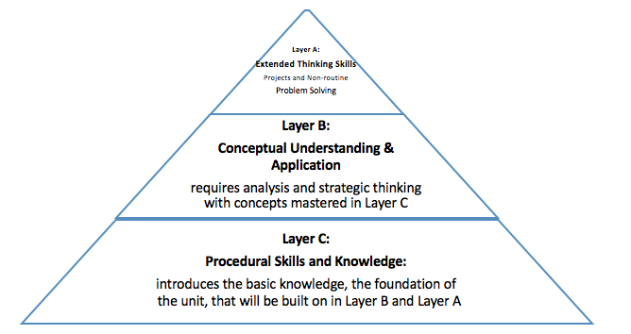

Sample Layered Curriculum - Geometry
Section 1: Layer C  65 points possible | Section 2: Layer B  Pick only one  15 points possible | Section 3: Layer A  Pick only one 20 points possible
- Identify and describe similarities and differences of triangles, and of quadrilaterals. 15pts  - Make a polygon picture book label each picture 5pts  - Make your own picture using only polygons, color and frame it. 15pts  - Complete worksheet on angles 10pts  - Make a math journal of 5 different sizes of circles. Find the circumference and diameter of circle 15pts  - Watch video on angles and working with lines and write a one page report 10pts  - Look through magazines and find pictures of polygons, angles, and circles, label them 10pts  - Go around town and take pictures of polygons in our world 10pt | 1. Create a game using polygons, angles and circles.  2. Create a book with polygons as the characters. Make sure it tells a story related to geometry.  3. Looking around your town what polygons do you see? For what kinds of jobs do you think it would be important to know the different types of polygons? | 1. If you could build a building using only the knowledge you have about polygons, angles and circles what would you build and how would you build it. Explain why you would build it that way. You may either type a one page paper or build a model and present to the class.  2. Find two famous structures (buildings) that use polygons in their shape. Explain the polygons in the structure and how it helps to stabilize the structure. Do you think a different shape could have done the same job? You may type a one page paper or build a bridge and present to the class
Adapted from: Kathie Nunley's Layered Curriculum®: http://help4teachers.com/PolygonsGrade8.htm

