ASSIGNMENT A

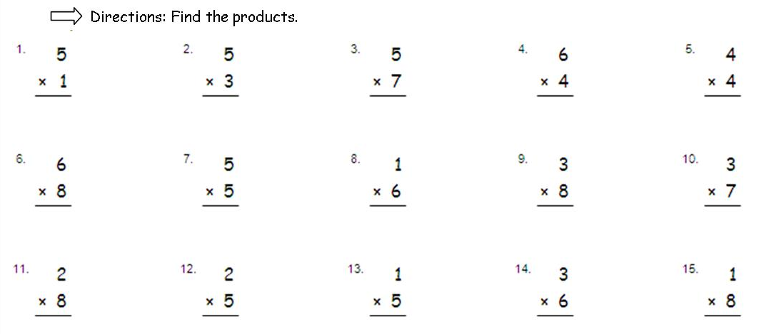

ASSIGNMENT C

Rational Numbers and the Coordinate Plane

In math class, Christina and Brett are debating the relationship between two rational numbers. Read their claims below, and then write an explanation of who is correct. Use a number line model to support your answer.

Christina’s Claim:
“I know that 3 is greater than 2 ½, so -3 must be greater than
-2 ½.”

Brett’s Claim:
“Yes, 3 is greater than 2 ½, but when you look at their opposites, their order will be opposite. So that means
-2 ½ is greater than -3.”

ASSIGNMENT E
