Domain – Cluster – Standards SORT
Read each standard. Decide which component(s) of rigor the standard best supports. Record the standard key code with a brief justification of your placement.
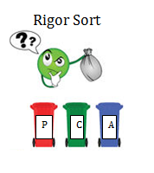

Procedural Skills  and Fluency | Conceptual Understanding | Modeling/  Real-world Application

