Analyzing Mathematics Assignments

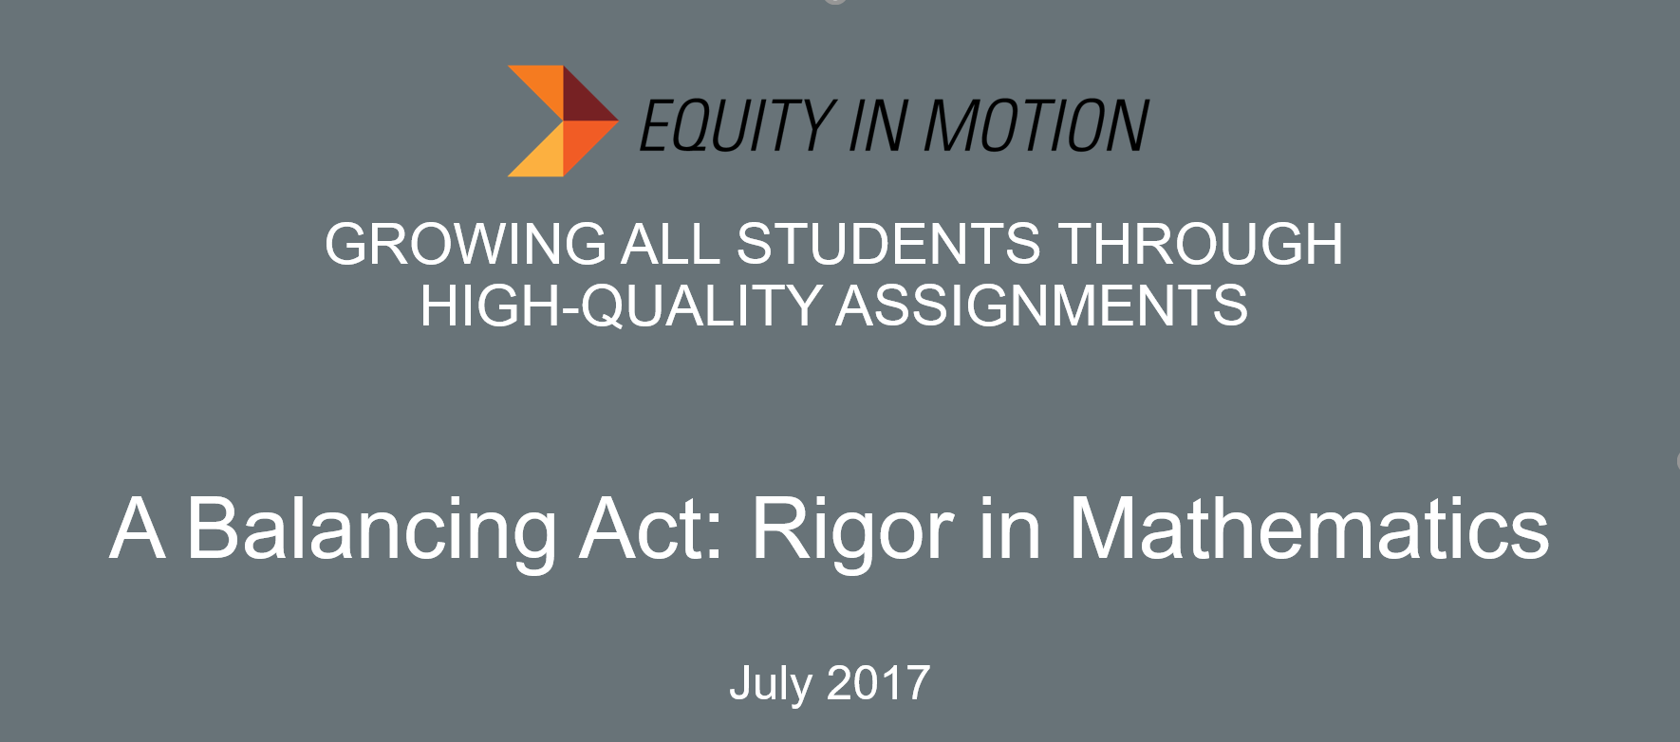

ASSIGNMENT A

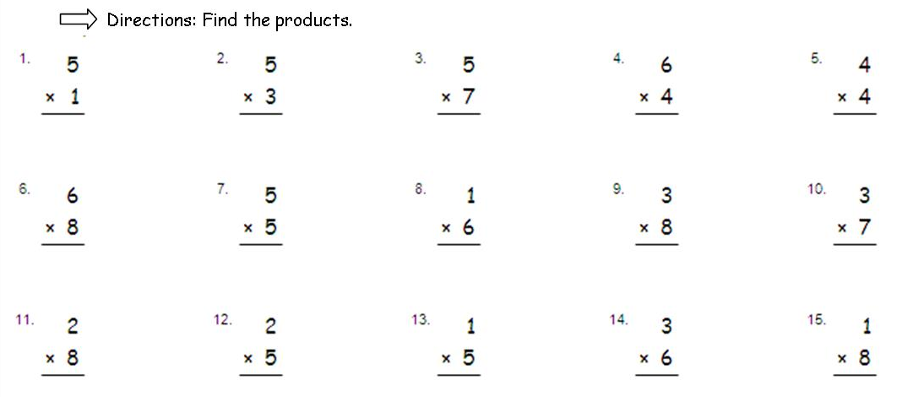

ASSIGNMENT B

Grayson is making cake for his sister’s volleyball team. He is going to use white frosting to make a circular volleyball on top of the cake. He wants the volleyball to be as large as possible. It takes 0.15 ounces of frosting to cover on square inch of the volleyball.

- Sketch the top of the cake with a circular volleyball. Label the sketch with at least 2 different measurements.

- How many ounces of frosting will Grayson need to make the volleyball? Justify your answer.

ASSIGNMENT C

Rational Numbers and the Coordinate Plane

In math class, Christina and Brett are debating the relationship between two rational numbers. Read their claims below, and then write an explanation of who is correct. Use a number line model to support your answer.

Christina’s Claim:
“I know that 3 is greater than 2 ½, so -3 must be greater than
-2 ½.”

Brett’s Claim:
“Yes, 3 is greater than 2 ½, but when you look at their opposites, their order will be opposite. So that means
-2 ½ is greater than -3.”

ASSIGNMENT D
Designing a Fence
You and your group members are designing a school garden. The principal has provided a 100ft² plot of land, which measures 10 feet on each side. The grid below represents the plot of land; each unit represents 1 foot.

You and your group need to build a fence to protect your garden from pests. The only guidelines are that
- Your garden must have at least 4 sides; and
- Your garden must be closed on all sides.

With your group, determine what kind of fence you and your classmates will build. Use the grid provided above to sketch your group’s fence. Then, discuss and answer the following:
- How many feet of fencing will you need to build your fence?
- Find the area enclosed by your fence using two different methods. Describe the methods used and why they result in the same area.
- What are the advantages and disadvantages of each method?

ASSIGNMENT E
